Remote Podcast Recording Options

Option #1: Record via Zoom

Select Zoom settings—Audio
- Change Suppress Background Noise from “Auto” to “Low”
- Check “Show in-meeting option to turn on original sound”
- Check “High fidelity music mode”
- Check “Echo cancellation”
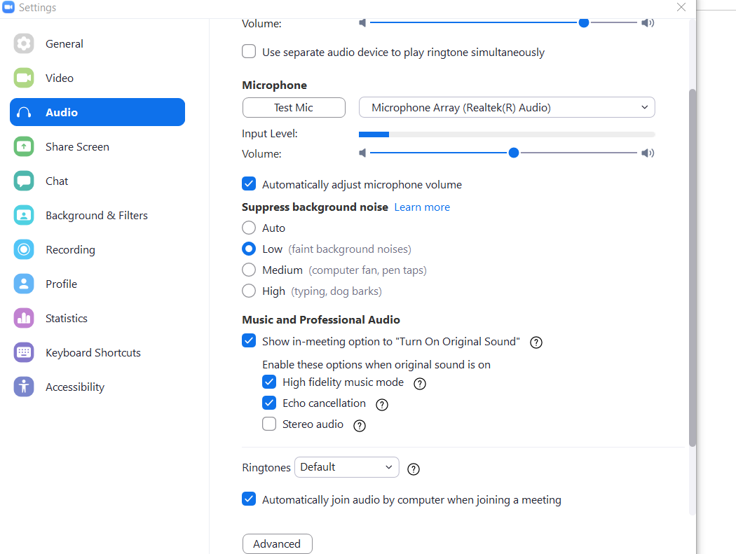

Under Zoom Settings—Recording
- Check “Record separate audio file for each participant”
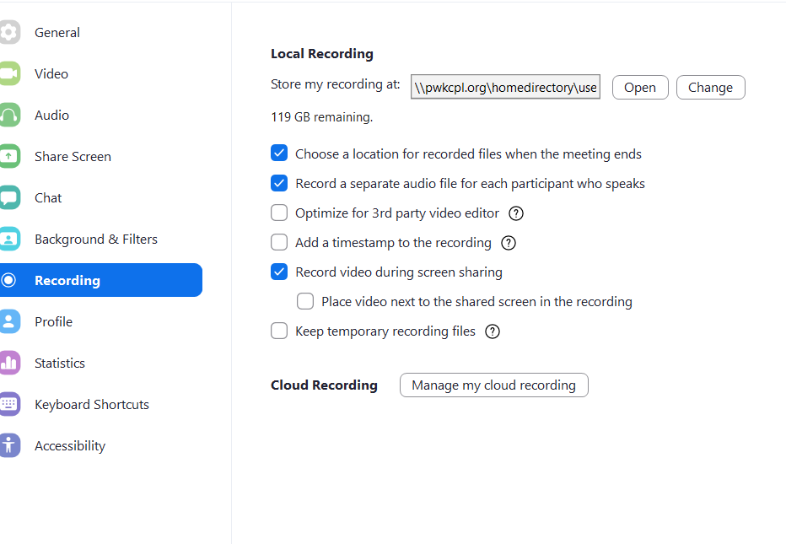

Then, simply record the discussion using Zoom just like you would any other meeting

Option #2: Record offline to Audacity

Using this option, you can use Zoom to watch and listen to other participants, but each person records their own voice directly into their computer with the Audacity software. Then the recordings are stitched together after the fact.
Zoom settings:
- Make sure that you have selected your headset or onboard microphone as the audio input *not* your regular microphone
- You will need to use headphones to hear the other person, be sure this is also selected in your Zoom audio settings.
- Record the meeting on Zoom. Even though you are recording with higher quality to Audacity, it will be very helpful to have a backup if something goes wrong!
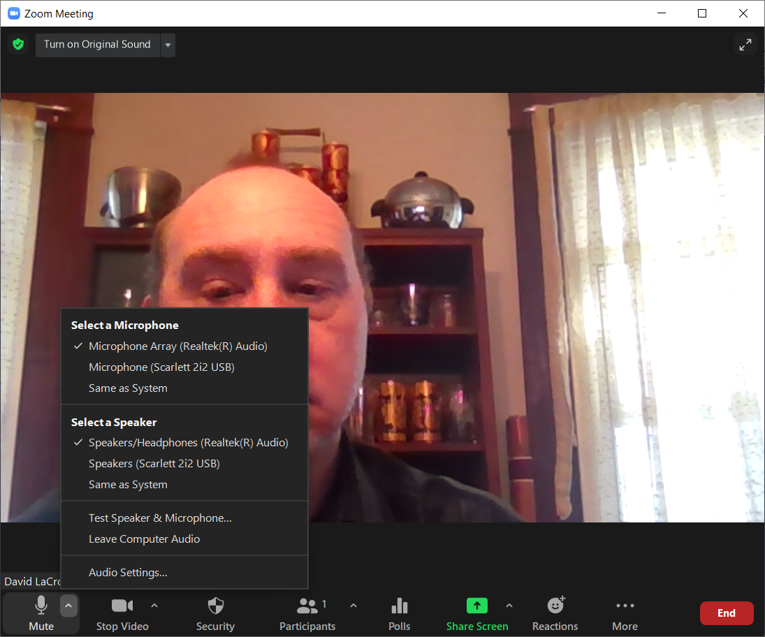

Audacity Settings:
Open Audacity. It should be installed on your computer already.
- Select the input for your Audio Interface or Microphone
- Change the default setting from Stereo to Mono
- Select your headphones as your speakers
- Click next to the upper microphone to start monitoring audio and test your mic

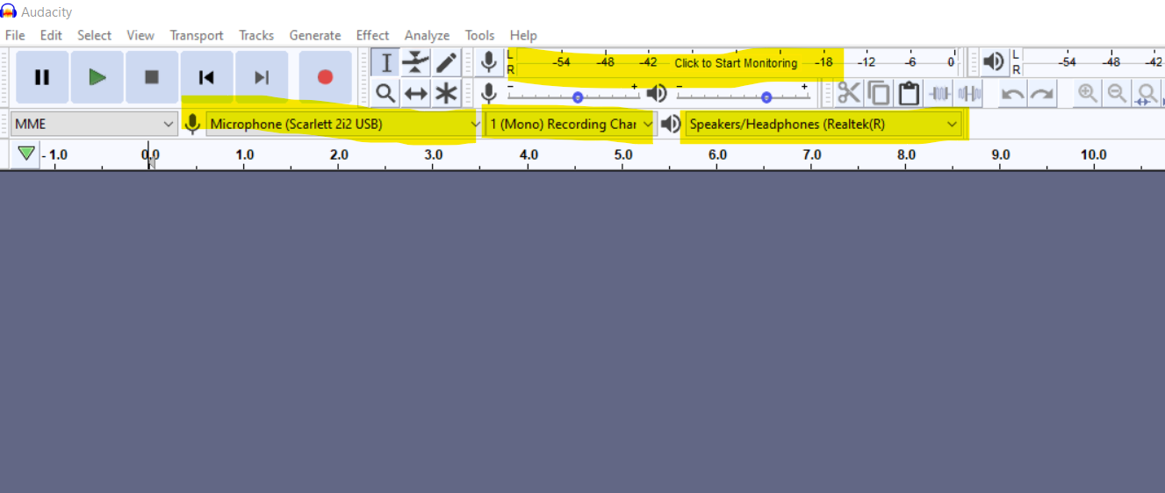

- Click the Record button (red dot) when you are ready to start

Best Practices for Recording
All participants should use headphones to avoid sound bleed and echo
Use a windscreen on your mic if you have one
Stay close to the microphone when you’re speaking
Preferred microphone setup from best to worst:
- XLR microphone with audio interface
- USB microphone
- Onboard mic
- Headset / Bluetooth device

